**The bad outcome of the abnormal situation can lead to stronger feelings of regret: conclusion from the classic experiment**

**Yiyan Zhang**

**Feb 10, 2024**

**Abstract**

Regret is a negative emotion associated with past decisions or actions, and it occurs when we think we could have avoided a bad outcome with different choices or actions. This paper discusses and validates the influence of norm theory and exceptionality effect on regret psychology by replicating three classic experiments from the paper of “The impact of past behaviour normality on regret: replication and extension of three experiments of the exceptionality effect” (Kahneman, D.and Miller, D. T. (1986)).

According to norm theory, individuals are less likely to feel regret when their actions conform to the self or social norm framework, because their actions conform to their own or society's expectations. Exceptionality effect refers to the tendency of individuals to consider exceptions or marginal cases while ignoring basic rules in the decision-making process.

Through conducting an experiment on interviewee with the questionnaire questions designed according to three scenarios(hitchhiking scenario, car accident scenario and roberry sceario) , norm theory and exceptionality effect have been effectively verified. In all three scenarios, people under exceptional circumstances are more likely to feel regret than under routine circumstances when faced with bad results.

**table of content**

1 Introduction 2

2 Data 3

2.1 Overview 3

2.2 Cleand data 3

2.3 Results 3

3 Discussion 8

References 10

# 1 Introduction

Regret is a negative emotion associated with past decisions or actions, and it occurs when we think we could have avoided a bad outcome with different choices or actions. The bad outcome of an unusual situation often increases feelings of regret. The emotion of regret often arises from comparing the actual situation with other possible situations and outcomes.

Kahneman and Miller (1986) proposed Norm Theory, which explains how individuals evaluate their decisions and behaviors through the concepts of norm framework, norm difference, norm selection and norm comparison. According to normative theory, when individuals act in line with their normative framework, the likelihood of regret is reduced because they acted in line with their own or others' expectations. Conversely, when behavior does not conform to the normative framework, normative differences increase, and so does the likelihood of regret, as individuals realize that their behavior did not meet the expected level, or violated their expectations or those of others.

According to recent studies (Byrne, 2016; Bear and Knobe, 2017; Dixon and Byrne; 2011; McEleney and Byrney, 2006), the exceptionality effect was proposed, which means that when individuals make decisions, they may pay more attention to those situations that are different from the normal situations, while ignoring the more typical ones. Exceptionality effect refers to the tendency of individuals to consider exceptions or marginal cases while ignoring basic rules in the decision-making process. After making a decision, individuals may be more likely to feel regret if a bad outcome occurs in exceptional circumstances, because they may think that the outcome might have been better if they had followed a more routine rule or choice.

In order to verify the norm theory and the exception effect, the classic experiment containing three hypothetical scenarios conducted by Kahneman, D.and Miller, D. T. (1986) are replicated in this paper. The first scenario was the hitchhiking scenario. In the first scenario, Mr. Jones hardly ever hitchhiked, while Mr. Smith often hitchhiked. Yesterday, they gave someone a ride, and they both got robbed. Mr. Jones represents the exception, while Mr. Smith represents the norm.

The second scenario was a car accident scenario. In the second scenario, Mr. Adam and Mr. White were both involved in a car accident on their way home from work. The difference is that Mr. Adam takes the route he usually takes after work, while Mr. White takes the route he doesn't usually take. Mr. Adam represents the exception situation, while Mr. White represents the normal situation.

In the third scenario(robbery scenario), it is assumed that there are 3 conditions, including Routine behavior condition(Mr. Paul often went to store A, and he was robbed and injured at store A at night.), Self-produced exception condition(Mr. Paul went to store B which he did not often go to, and he was robbed and injured at store B at night.) and Other-produced exception condition(Mr. Paul went to store B because store A did not open, and he was robbed and injured at store B at night.). Respondents are required to fill in the degree of regret(1-5) and the amount of compensation (0-10) they think should pay in three conditions.

The researchers randomly selected 342 respondents and conducted questionnaire survey containing three scenario hypotheses. Regret will be measured by responses to questions in the questionnaire.

# 2 Data

## 2.1 Overview

The datasets for this report were obtained from the data section for “The impact of past behaviour normality on regret: replication and extension of three experiments of the exceptionality effect” (Lucas Kutscher and Gilad Feldman (2019)), a paper from the Cognition and Emotion. This paper is a replication of the paper of “The impact of past behaviour normality on regret: replication and extension of three experiments of the exceptionality effect” (Lucas Kutscher and Gilad Feldman (2019)). The datasets for this report contain the questionnaire information data of the three experiments in this paper. Analysis of these data helps to understand the scale and severity of the problem of partner violence.

Using the R programming language (R Core Team 2022), the jmv and dplyr (Wickham et al. 2022) packages were used to conduct data analysis and processing.

The variable of Sc1_regret represents the answer of the question of "Who experiences higher regret (direct replication)". The variable of Sc1_socnorms1 represents the answer of the question of “Descriptive norms - which is more common?”. The variable of Sc1_socnorms2 represents the answer of the question of “Injunctive norms - who is more criticized by society?”. The variable of Sc1_ combinednorms represents the answer of the question of “Who experiences higher regret, when asking participants to consider the norm?”.

Sc2_random_1 and Sc2_random_2 range from 1 to 7, representing the randomness of the emotion-“Adam's (Routine) accident is a random coincidence” and “White's' (Exception) accident is a random coincidence”. The larger the number chosen by the respondent, the more the representative agrees with the question statement. Sc2_ lucky represents the answer of the question of “Who is less lucky?”. Sc2_regret measures the degree of regret-"Who feels more upset (direct replication)".

## 2.2 Cleand data

In order to process the data, this paper deleted the data whose variables were all NA. Moreover, in order to make the variables easier to understand, I used specific names instead of numbers in the questionnaire. For Sc1_regret, sc1_socnorms1, sc1_socnorms2 and sc1_combinednorms, the paper replace 1 with "Exception Jones", and replace 2 with "Routine Smith". (Hitchhiker-Scenario) For Sc2_regret, replace 1 with "Routine Adams", and 2 with "Exception White". For Sc2_lucky, replace 1 with " Adams less lucky", and 2 with " White less lucky".(Car Accident-Scenario)

## 2.3 Results

After loading the dataset using the R programming language (R Core Team 2022), the ggplot2 package was use to generate charts. The following tables were generated by the jmv package.

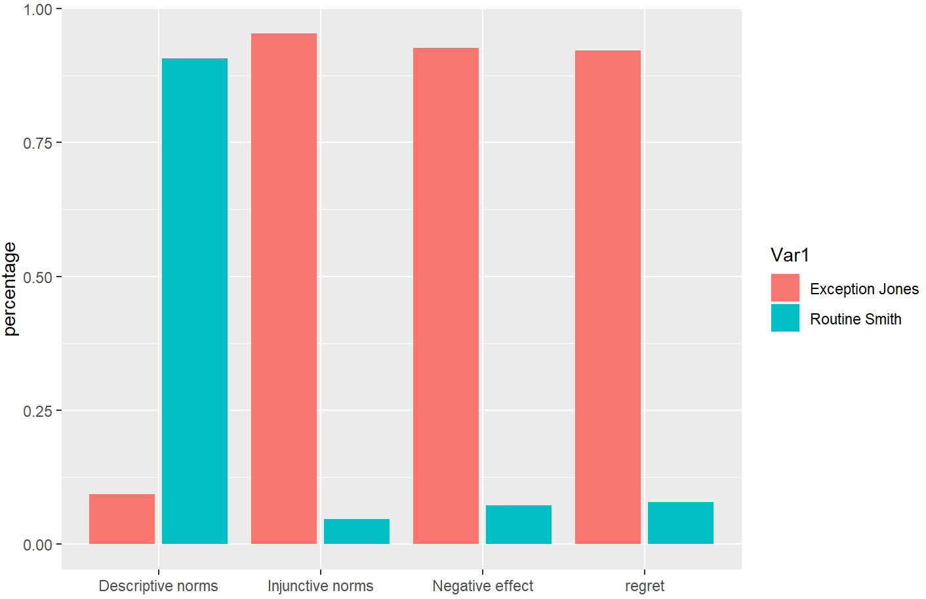

**Figure 1. Scenario 1: Proportions for perceived regret, injunctive social norms, descriptive social norms, and negative affect. (Hitchhiker-Scenario)**

|  |  |  |  |  |  |  |  |  |
| --- | --- | --- | --- | --- | --- | --- | --- | --- |
|  | Regret | | Social norm(injunctive) | | Social norm(descriptive) | | negative effect | |
|  | Count | % | Count | % | Count | % | Count | % |
| Exception Jones | 315 | 92.1% | 326 | 95.3% | 32 | 9.4% | 317 | 92.7% |
| Routine Smith | 27 | 7.9% | 16 | 4.7% | 310 | 90.6% | 25 | 7.3% |

**Table 1. counts and proportions for regret, Social norm(injunctive),** **Social norm(descriptive) and negative effect (Hitchhiker-Scenario)**

Based on Fig 1 and Table 1, it can be seen that under exceptional circumstances, people are more likely to have regret feelings than under normal circumstances when faced with bad results. For social norms, more than 90 percent of respondents believed that Jones, who represents an exception, would be criticized by society. For descriptive norms, more than 90 percent of respondents believed that Smith’s behaviour is morecommon in society. As for negative effect, more than 90 percent of respondents believed that Jones experiences higher regret, when asking participants to consider the norm.

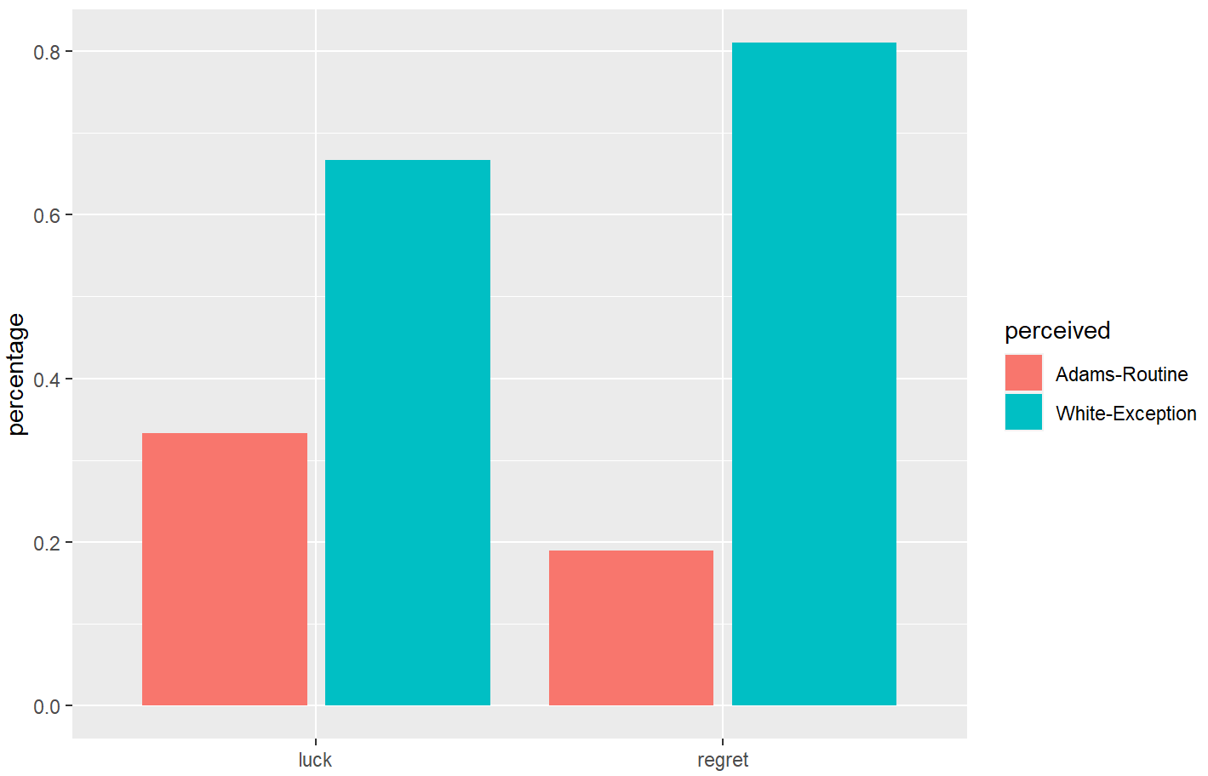

**Figure 2 Scenario 2: Proportions for perceived regret and luck. (Car Accident-Scenario)**

|  |  |  |  |  |
| --- | --- | --- | --- | --- |
|  | Regret | | Social norm(injunctive) | |
|  | Count | Proportion | Count | Proportion |
| Exception Whites | 277 | 81.0% | 228 | 66.7% |
| Routine Adams | 65 | 19.0% | 114 | 33.3% |

**Table 2. counts and proportions for regret, Social norm(injunctive),** **Social norm(descriptive) and negative effect (Hitchhiker-Scenario)**

Based on Fig 2 and Table 2, more than 80 percent of respondents believed that White, who represents an exception, would be more regret when invovled in car accident. Moreover, more than 60 percent of respondents believed that White would be less lucky because he took a took a route he did not usually take. In total, under car Accident-Scenario, it can be seen that under exceptional circumstances, people are more likely to have regrets than under normal circumstances when faced with bad results.

|  |  |  |  |  |  |  |
| --- | --- | --- | --- | --- | --- | --- |
|  | Compensation | | | Regret | | |
|  | N | M | SD | N | M | SD |
| Routine | 114 | 5.34 | 2.37 | 114 | 3.95 | 1.12 |
| Self-produced exception | 115 | 5.72 | 2.46 | 115 | 4.53 | 0.80 |
| Other-produced exception | 113 | 5.41 | 2.76 | 113 | 4.32 | 0.94 |

**Table 3. data size, mean and standard deviation for regret and compensation (Robbery Scenario)**

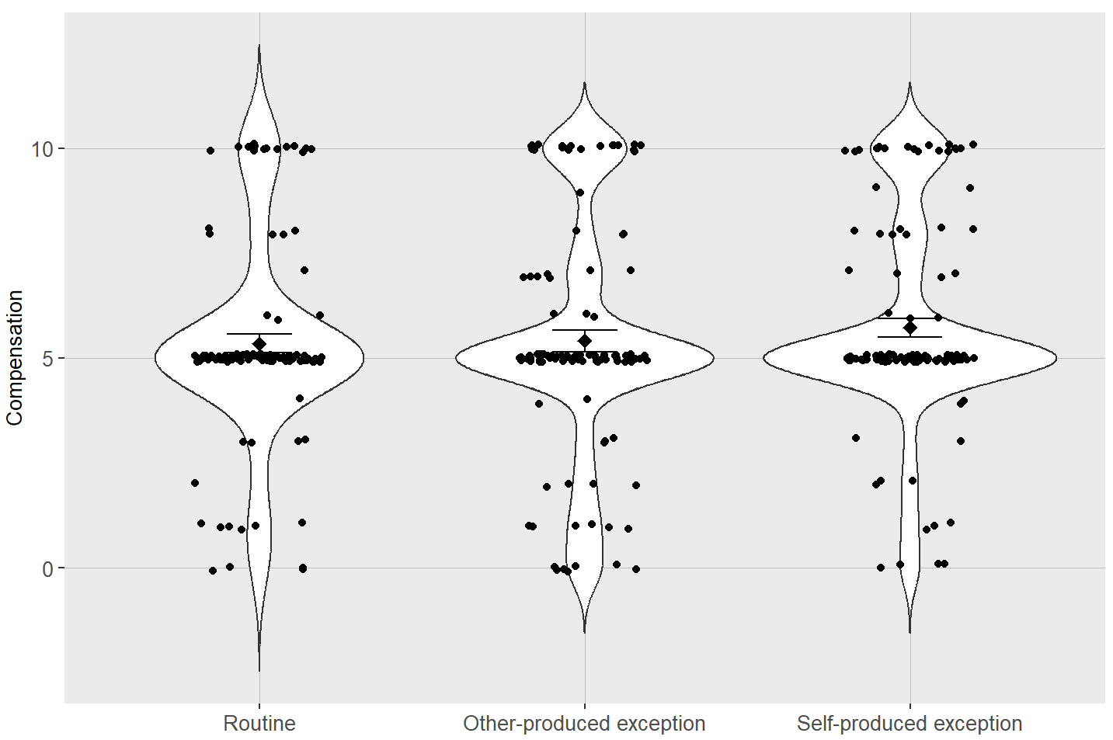

**Figure 3 Scenario 3: The amount of compensation the respondent thought should be paid. (Robbery Scenario)**

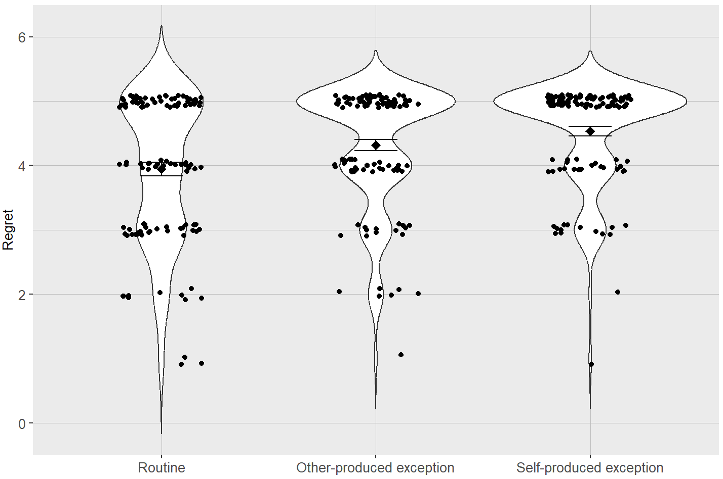

**Figure 4 Scenario 3: Proportions for perceived regret. (Robbery Scenario)**

Based on Fig 3 and Fig 4, the distribution of compensation that respondents believe should be paid to victims in routine situation differs little from the distribution of compensation to victims in other-produced exception situation and to victims in self-produced exception situation. However, respondents think that the victim's degree of regret in other-produced exception situation and self-produced exception situation is significantly higher than that in routine situation.

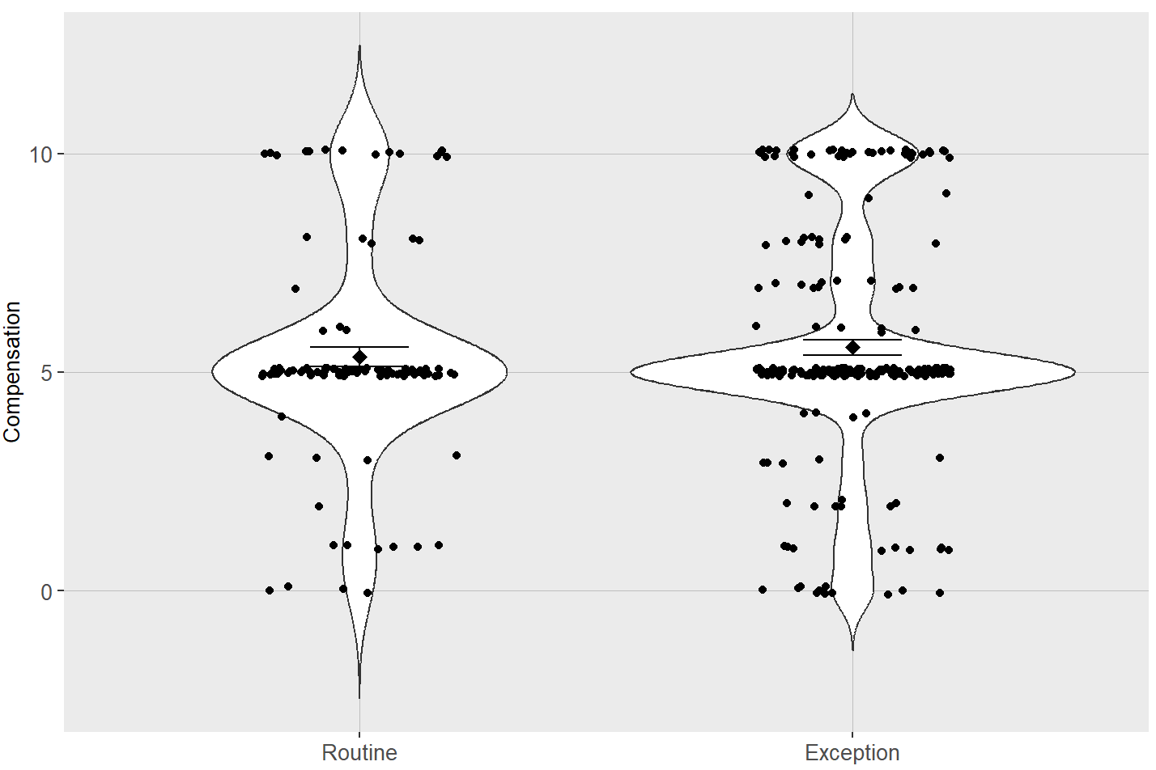

**Figure 5 Scenario 3: The amount of compensation the respondent thought should be paid. (Robbery Scenario)**

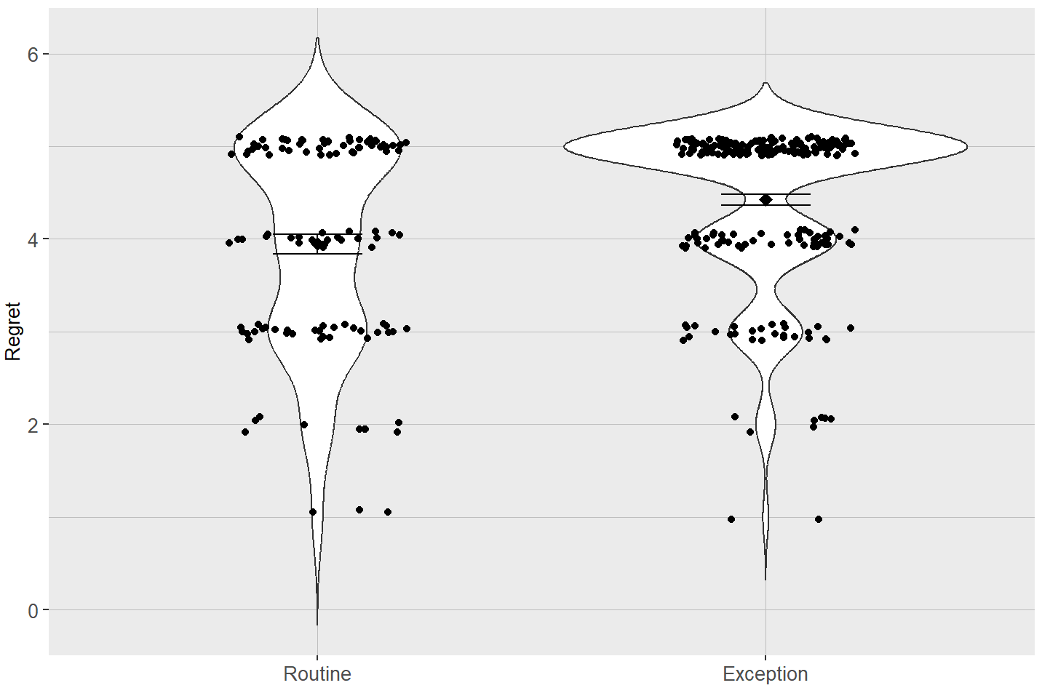

**Figure 6 Scenario 3: Proportions for perceived regret. (Robbery Scenario)**

Based on Fig 5 and Fig 6, camparing with routine situation, respondents' perceived degree of regret was more concentrated in 5 under exceptional cases, which represented the highest degree of regret. More respondents thought compared to the normal situation, in exceptional cases, the degree of victim being robbed regret is higher. Moreover, camparing with routine situation, respondents believe that compensation for victims under exceptional cases should be more distributed, and more people believe that compensation for victims under exceptional cases should be between $500,000 and $1,000,000.

# 3 Discussion

Through conducting an experiment on interviewee with the questionnaire questions designed according to three scenarios(hitchhiking scenario, car accident scenario and roberry sceario) , norm theory and exceptionality effect have been effectively verified. In all three scenarios, people under exceptional circumstances are more likely to feel regret than under routine circumstances when faced with bad results.

In scenario 1, 92.1 percent of respondents believed that Jones, who represents an exception, would be more regret. For norms, 90.6 percent of respondents believed that Smith’s behaviour is more common in society and 95.3 percent of respondents believed that Jones, who represents an exception, would be criticized by society. As for negative effect, 92.7 percent of respondents believed that Jones experiences higher regret, when asking participants to consider the norm. The results suggest that social norms do influence regret.

In scenario 2, 81 percent of respondents believed that White, who represents an exception, would be more regret when invovled in car accident. Moreover, 66.7 percent of respondents believed that White would be less lucky because he took a took a route he did not usually take. In scenario 3,

more respondents thought compared to the normal situation, in exceptional cases(both other-produced exception situation and self-produced exception situation), the degree of victim being robbed regret is higher, who should be compensated more.

To conclude, through conducting an experiment on interviewee with the questionnaire questions designed according to three scenarios(hitchhiking scenario, car accident scenario and roberry sceario) , norm theory and exceptionality effect have been effectively verified.

# References

Alexander, Rohan. 2023. Telling Stories with Data. Boca Raton: CRC Press. https://tellingstorieswithdata.com/.

Lucas Kutscher & Gilad Feldman (2019) The impact of past behaviour normality on regret: replication and extension of three experiments of the exceptionality effect, Cognition and Emotion, 33:5, 901-914, DOI: 10.1080/02699931.2018.1504747

Kahneman, D., & Miller, D. T. (1986). Norm theory: Comparing reality to its alternatives. Psychological Review, 93, 136–153.

Byrne, R. M. (2016). Counterfactual thought. Annual Review of Psychology, 67, 135–157.

Bear, A., & Knobe, J. (2017). Normality: Part descriptive, part prescriptive. Cognition, 167, 2 5–37.

Dixon, J. E., & Byrne, R. M. (2011). “If only” counterfactual thoughts about exceptional actions. Memory & Cognition, 39, 1317–1331.

McEleney, A., & Byrne, R. M. (2006). Spontaneous counterfactual thoughts and causal explanations. Thinking & Reasoning, 12,235–255.

N’gbala, A., & Branscombe, N. R. (1997). When does action elicit more regret than inaction and is counterfactual mutation the mediator of this effect? Journal of Experimental Social Psychology, 33, 324–343.

Koehler, J. J., & Prentice, R. A. (2003). A normality bias in legal decision making. Cornell Law Review, 88, 583–645.

R Core Team. 2023. R: A Language and Environment for Statistical Computing. Vienna, Austria: R Foundation for Statistical Computing. https://www.R-project.org/.